What Is Insertion Sort?
In a simple insertion sort algorithm, we maintain a sorted and an unsorted subarray of the given array. In each iteration, one value from the unsorted part is picked and is inserted in its correct position in the sorted part. To achieve this, for every element, we iterate over the sorted part of the array to find the position to insert the element.
So, it takes O(N) comparisons and O(N) swaps for inserting one element in the worst case (last element). How can we optimize it?
For a detailed explanation of the insertion sort algorithm, check out “Learn the Insertion Sort Algorithm.”

What Is Binary Insertion Sort?
Binary insertion sort is a sorting algorithm similar to insertion sort, but instead of using linear search to find the position where the element should be inserted, we use binary search. Thus, we reduce the number of comparisons for inserting one element from O(N) to O(log N).
It is an adaptive algorithm, which means that it works faster when the given array is already substantially sorted, i.e., the current position of the element is near its actual position in the sorted array.
It is a stable sorting algorithm — the elements with the same values appear in the same order in the final array as they were in the initial array.

Applications of Binary Insertion Sort
Binary insertion sort works efficiently when the array has a low number of elements.
While performing quicksort or merge sort, when the subarray’s size becomes small (say <=25 elements), it’s more efficient to use binary insertion sort.
This algorithm is also efficient when the cost of comparison between keys is sufficiently high. For example, if we want to sort an array of strings, the comparison operation of two strings will be high.

How Does Binary Insertion Sort Work?
In binary insertion sort, we divide the array into two subarrays — sorted and unsorted. The first element of the array is in the sorted subarray, and the rest of the elements are in the unsorted one.
We then iterate from the second element to the last element. For the i-th iteration, we make the current element our “key.” This key is the element that we have to add to our existing sorted subarray.
To do this, we first use binary search on the sorted subarray to find the position of the element that is just greater than our key. Let’s call this position “pos.” We then right shift all elements from position pos to i-1 and then make Array[pos] = key.
We can note that for every i-th iteration, the left part of the array till (i-1) is always sorted.

Binary Insertion Sort Example
Suppose we need to sort the following array:

- We assume that the first element is already sorted.
- We take the second element and store it in a variable (key).
- Now, we use binary search to find the element on the left of the current element, which is just greater than it.
- In this case, we have only one element, 8, and it is greater than 6. So, we shift 8 one index towards the right and place 6 at its position.
The array now looks like this:

- Now, we take the third element, 1. Note that all the elements before the current element are sorted.
- We store 1 in key and find the element just greater than 1 in the sorted part using binary search.
- Here, the required element is 6. So, we shift 6 and 8 one index towards the right and place 1 at the position of 6 before shifting.
The array now looks like this:

- We now take the 4th element, 5, and store it in key.
- Using binary search, we find the element just greater than 5 in the sorted part. In this case, the required element is 6.
- Again, we shift 6 and 8 one index towards the right and place 5 at the position of 6 before shifting.
The array now looks like this:

- We now take the last (5th) element, which is 3, and find the element just greater than it in the sorted part.
- The required element is 5. We shift 5, 6, and 8 one index towards the right and place 3 at the position of 5 before shifting.
The resulting array is:

We have sorted the given array using binary insertion sort.

Binary Insertion Sort Algorithm
Binary insertion sort for array A:
- Step 1: Iterate the array from the second element to the last element.
- Step 2: Store the current element A[i] in a variable key.
- Step 3: Find the position of the element just greater than A[i] in the subarray from A[0] to A[i-1] using binary search. Say this element is at index pos.
- Step 4: Shift all the elements from index pos to i-1 towards the right.
- Step 5: A[pos] = key.

Binary Insertion Sort Pseudocode
‍

Binary Insertion Sort Code

Output
The array after 1 iterations = 6 8 1 5 3
The array after 2 iterations = 1 6 8 5 3
The array after 3 iterations = 1 5 6 8 3
The array after 4 iterations = 1 3 5 6 8

Binary Insertion Sort Complexities

Time Complexity Analysis

Worst Case
For inserting the i-th element in its correct position in the sorted, finding the position (pos) will take O(log i) steps. However, to insert the element, we need to shift all the elements from pos to i-1. This will take i steps in the worst case (when we have to insert at the starting position).
We make a total of N insertions — so, the worst-case time complexity of binary insertion sort is O(N^2).
This occurs when the array is initially sorted in descending order.

Best Case
The best case will be when the element is already in its sorted position. In this case, we don’t have to shift any of the elements; we can insert the element in O(1).
But we are using binary search to find the position where we need to insert. If the element is already in its sorted position, binary search will take (log i) steps. Thus, for the i-th element, we make (log i) operations, so its best-case time complexity is ?(N log N).
This occurs when the array is initially sorted in ascending order.

Average Case
For average-case time complexity, we assume that the elements of the array are jumbled. Thus, on average, we will need O(i /2) steps for inserting the i-th element, so the average time complexity of binary insertion sort is ?(N^2).

Space Complexity Analysis
Binary insertion sort is an in-place sorting algorithm. This means that it only requires a constant amount of additional space. We sort the given array by shifting and inserting the elements.
Therefore, the space complexity of this algorithm is O(1) if we use iterative binary search. It will be O(logN) if we use recursive binary search because of O(log N) recursive calls.

Strengths and Weaknesses of Binary Insertion Sort
Binary insertion sort works efficiently for smaller arrays (<= 25 elements). This algorithm also works well for almost-sorted arrays, where the elements are near their position in the sorted array.
However, when the size of the array is large, the binary insertion sort doesn’t perform well. We can use other sorting algorithms like merge sort or quicksort in such cases.
Making fewer comparisons is also one of the strengths of this sorting algorithm; therefore, it is efficient to use it when the cost of comparison is high.

Insertion Sort vs. Binary Insertion Sort
As stated earlier, binary insertion sort is an improvement of insertion sort. We reduce the number of comparisons in insertion sort by using binary search instead of linear search.

Note: Both the algorithms are in place and use O(1) space complexity. However, if we use recursive binary search in binary insertion sort, its space complexity will become O(log N) due to O(log N) recursive calls.

FAQs on Binary Insertion Sort
Question 1. Is Binary insertion sort a stable sorting algorithm?
Answer: Yes, binary insertion sort is a stable sorting algorithm. This means that two different elements with the same value will appear in the same order in the final sorted array as they appeared in the initial array.
In each iteration, we find the element’s position just greater than our current element in the sorted subarray and insert it there. Thus, if there were any other elements with the same value before our current element in the initial array, they will be present before it in the final sorted array.
Question 2. Which sorting algorithm between binary insertion sort and bubble sort uses fewer swaps?
Answer: Both binary insertion sort and bubble sort use the same number of swaps. For an element at index “i” in the initial array, if its position in the sorted array is “j,” both the algorithms will take abs(i-j) swaps to place it in its sorted position. The total number of swaps used in both the algorithms is equal to the inversion count of the array.
Question 3. How many maximum comparisons will be made in binary insertion sort in one iteration?
Answer: O(Log N). This will happen when we are in the n-th iteration, and the position where the current element should be inserted is such that the binary search takes O(log N) steps.

Are You Ready to Nail Your Next Coding Interview?
Sorting algorithms interview questions feature in almost every coding interview for software developers. If you’re looking for guidance and help to nail these questions and more, sign up for our free webinar.
As pioneers in the field of technical interview prep, we have trained thousands of software engineers to crack the toughest coding interviews and land their dream jobs at Google, Facebook, Apple, Netflix, Amazon, and other Tier-1 tech companies.
-------------------------------------------------------------------------------------------------------------------------
Binary insertion sort is a sorting algorithm similar to insertion sort, but instead of using linear search to find the position where the element should be inserted, we use binary search. Thus, we reduce the number of comparisons for inserting one element from O(N) to O(log N)

Binary Insertion Sort

Introduction
Binary insertion sort is a sorting algorithm similar to insertion sort, but instead of using linear search to find the position where the element should be inserted, we use binary search. Thus, we reduce the number of comparisons for inserting one element from O(N) (Time complexity in Insertion Sort) to O(log N).

Best of two worlds
Binary insertion sort is a combination of insertion sort and binary search.
Insertion sort is sorting technique that works by finding the correct position of the element in the array and then inserting it into its correct position. Binary search is searching technique that works by finding the middle of the array for finding the element.
As the complexity of binary search is of logarithmic order, the searching algorithm’s time complexity will also decrease to of logarithmic order. Implementation of binary Insertion sort. this program is a simple Insertion sort program but instead of the standard searching technique binary search is used.

How Binary Insertion Sort works ?

Process flow:
In binary insertion sort, we divide the array into two subarrays — sorted and unsorted. The first element of the array is in the sorted subarray, and the rest of the elements are in the unsorted one.
We then iterate from the second element to the last element. For the i-th iteration, we make the current element our “key.” This key is the element that we have to add to our existing sorted subarray.

Example
Consider the array 29, 10, 14, 37, 14,
First Pass
Key = 1
Since we consider the first element is in the sorted array, we will be starting from the second element. Then we apply the binary search on the sorted array.
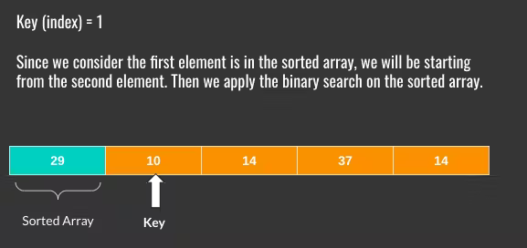
In this scenario, we can see that the middle element in sorted array (29) is greater than the key element 10 (key = 1).
Now we need to place the key element before the middle element (i.e.) to the position of 0. Then we can shift the remaining elements by 1 position.
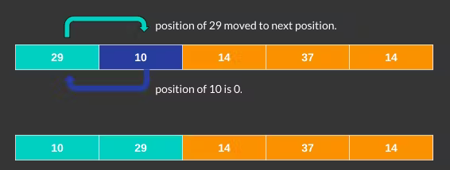
Increment the value of key.
Second Pass
Key = 2
Now the key element is 14. We will apply binary search in the sorted array to find the position of the key element.
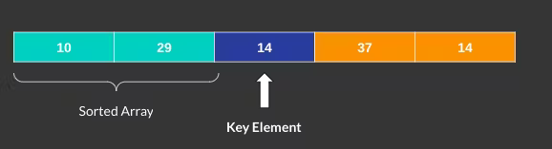
In this scenario, by applying binary search, we can see key element to be placed at index 1 (between 10 and 29). Then we can shift the remaining elements by 1 position.
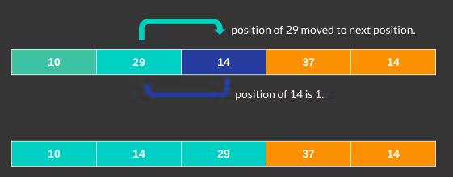
Third Pass
Key = 3
Now the key element is 37. We will apply binary search in the sorted array to find the position of the key element.
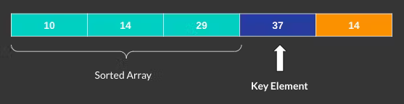
In this scenario, by applying binary search, we can see key element is placed in its correct position.
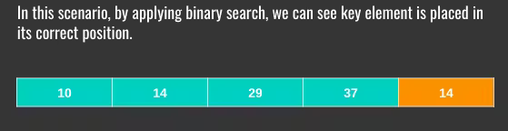
Fourth Pass
Key = 4
Now the key element is 14. We will apply binary search in the sorted array to find the position of the key element.
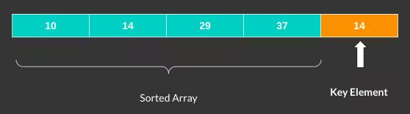
In this scenario, by applying binary search, we can see key element to be placed at index 2 (between 14 and 29). Then we can shift the remaining elements by 1 position.
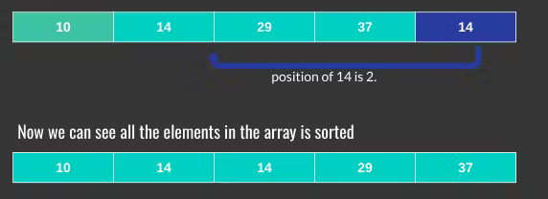
Now we can see all the elements are sorted.
1  2  3  4  5  6  7  8  9  10  11  12  13  14  15  16  17  18  19  20  21  22  23  24  25  26  27  28  29 | def binary_search(arr, key, start, end):  if start == end:  if arr[start] > key:  return start  else:  return start+1  if start > end:  return start  mid = (start+end)//2  if arr[mid] < key:  return binary_search(arr, key, mid+1, end)  elif arr[mid] > key:  return binary_search(arr, key, start, mid-1)  else:  return mid  def insertion_sort(arr):  total_num = len(arr)  for i in range(1, total_num):  key = arr[i]  j = binary_search(arr, key, 0, i-1)  arr = arr[:j] + [key] + arr[j:i] + arr[i+1:]  return arr  sorted_array = insertion_sort([29, 10, 14, 37, 14])  print("Sorted Array : ", sorted_array)

Complexity Analysis

Worst Case
For inserting the i-th element in its correct position in the sorted, finding the position (pos) will take O(log i) steps. However, to insert the element, we need to shift all the elements from pos to i-1. This will take i steps in the worst case (when we have to insert at the starting position).
We make a total of N insertions. so, the worst-case time complexity of binary insertion sort is O(N^2).
This occurs when the array is initially sorted in descending order.

Best Case
The best case will be when the element is already in its sorted position. In this case, we don’t have to shift any of the elements; we can insert the element in O(1).
But we are using binary search to find the position where we need to insert. If the element is already in its sorted position, binary search will take (log i) steps. Thus, for the i-th element, we make (log i) operations, so its best-case time complexity is O(N log N).
This occurs when the array is initially sorted in ascending order.

Average Case
For average-case time complexity, we assume that the elements of the array are jumbled. Thus, on average, we will need O(i /2) steps for inserting the i-th element, so the average time complexity of binary insertion sort is O(N^2).
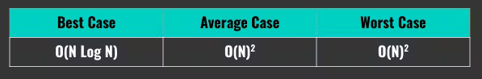

Space Complexity Analysis
Binary insertion sort is an in-place sorting algorithm. This means that it only requires a constant amount of additional space. We sort the given array by shifting and inserting the elements.
Therefore, the space complexity of this algorithm is O(1) if we use iterative binary search. It will be O(logN) if we use recursive binary search because of O(log N) recursive calls.

Is Binary Insertion Sort a stable algorithm
It is a stable sorting algorithm, the elements with the same values appear in the same order in the final array as they were in the initial array.

Cons and Pros
- Binary insertion sort works efficiently for smaller arrays.
- This algorithm also works well for almost-sorted arrays, where the elements are near their position in the sorted array.
- However, when the size of the array is large, the binary insertion sort doesn’t perform well. We can use other sorting algorithms like merge sort or quicksort in such cases.
- Making fewer comparisons is also one of the strengths of this sorting algorithm; therefore, it is efficient to use it when the cost of comparison is high.
- Its efficient when the cost of comparison between keys is sufficiently high. For example, if we want to sort an array of strings, the comparison operation of two strings will be high.

Bonus Section
Binary Insertion Sort has a quadratic time complexity just as Insertion Sort. Still, it is usually faster than Insertion Sort in practice, which is apparent when comparison takes significantly more time than swapping two elements.

Binary Search
We can use binary search to reduce the number of comparisons in normal insertion sort. Binary Insertion Sort find use binary search to find the proper location to insert the selected item at each iteration.
In normal insertion, sort it takes O(i) (at ith iteration) in worst case. we can reduce it to O(logi) by using binary search.
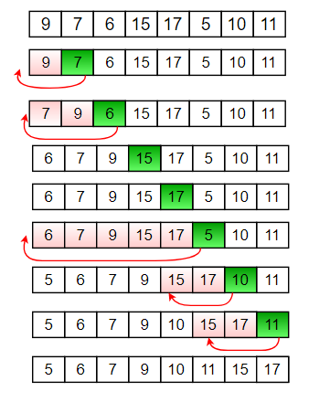
diagram for binary insertion sort

Implementation of Binary Insertion Sort in C
C
// C program for implementation of binary insertion sort
#include <stdio.h>

// A binary search based function to find the position
// where item should be inserted in a[low..high]
int binarySearch(int a[], int item, int low, int high)
{
if (high <= low)
return (item > a[low])? (low + 1): low;

int mid = (low + high)/2;

if(item == a[mid])
return mid+1;

if(item > a[mid])
return binarySearch(a, item, mid+1, high);
return binarySearch(a, item, low, mid-1);
}

// Function to sort an array a[] of size 'n'
void insertionSort(int a[], int n)
{
int i, loc, j, k, selected;

for (i = 1; i < n; ++i)
{
j = i - 1;
selected = a[i];

// find location where selected sould be inseretd
loc = binarySearch(a, selected, 0, j);

// Move all elements after location to create space
while (j >= loc)
{
a[j+1] = a[j];
j--;
}
a[j+1] = selected;
}
}

// Driver program to test above function
int main()
{
int a[] = {37, 23, 0, 17, 12, 72, 31,
46, 100, 88, 54};
int n = sizeof(a)/sizeof(a[0]), i;

insertionSort(a, n);

printf("Sorted array: \n");
for (i = 0; i < n; i++)
printf("%d ",a[i]);

return 0;
}
Output:
Sorted array:
0 12 17 23 31 37 46 54 72 88 100
Time Complexity: The algorithm as a whole still has a running worst case running time of O(n²) because of the series of swaps required for each insertion.
[ad type=”banner”]

